แบบฝึกหัด
วิชา ปัญญาประดิษฐ์ (Artificial Intelligence)

จัดทำโดย
นายชนะพล ชาคระธรรม 521733022001-8
นายธนายุทธ โพธิ์นอก 521733022008-3
นายกฤตย์ ชัยชนะ 521733022035-6
CPE 4/4

เสนอ
อาจารย์ธรรมกร ครองไตรภพ
สาขาวิศวกรรมคอมพิวเตอร์
คณะวิศวกรรมศาสตร์และสถาปัตยกรรมศาสตร์
มหาวิทยาลัยเทคโนโลยีราชมงคลอีสาน
รายงาน
เรื่อง โปรแกรม Iterative Deepening Search (IDS)
วิชา ปัญญาประดิษฐ์ (Artificial Intelligence)

จัดทำโดย
นายชนะพล ชาคระธรรม 521733022001-8
นายธนายุทธ โพธิ์นอก 521733022008-3
นายกฤตย์ ชัยชนะ 521733022035-6
CPE 4/4

เสนอ
อาจารย์ธรรมกร ครองไตรภพ
สาขาวิศวกรรมคอมพิวเตอร์
คณะวิศวกรรมศาสตร์และสถาปัตยกรรมศาสตร์
มหาวิทยาลัยเทคโนโลยีราชมงคลอีสาน

Iterative Deepening Search (IDS)
โจทย์ : จากรูป ให้เขียนโปรแกรมแสดงขั้นตอนการค้นหาโหนดใดๆ ด้วยวิธีการค้นหาแบบ Iterative Deepening Search
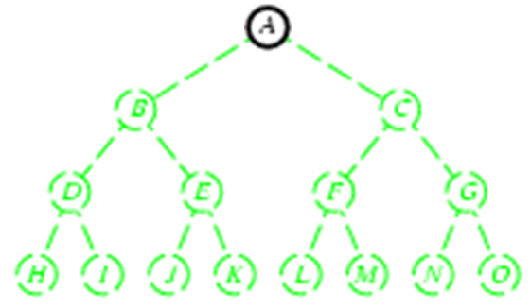

Iterative Deepening Search (IDS) หรืออีกชื่อหนึ่งคือ Iterative Deepening Depth-First Search (IDDFS) เป็นวิธีการค้นหาที่พัฒนาจาก Depth-Limited Search ให้มีประสิทธิภาพมากขึ้น โดยทำการค้นหาแบบ Depth-Limited Search ถ้าหากค้นหาโหนดเป้าหมายไม่พบ ก็จะเพิ่มระดับลิมิตขี้นโดยอัตโนมัติ แล้วค้นหาซ้ำใหม่ตั้งแต่ต้น ทำเช่นนี้ไปเรื่อยๆจนกว่าจะพบโหนดเป้าหมาย
วิธีการค้นหาแบบ Iterative Deepening Search นั้น เหมือนกับการนำจุดเด่นเรื่องประสิทธิภาพในการใช้หน่วยความจำของ Depth-Limited Search มารวมเข้ากับจุดเด่นเรื่องความสมบูรณ์ในการค้นพบคำตอบของ Breadth-First Search

ตัวอย่าง : กำหนดให้โหนด K เป็นโหนดเป้าหมาย และเพิ่มทีละ1 ระดับ โดยเริ่มจากระดับลิมิตที่ 0
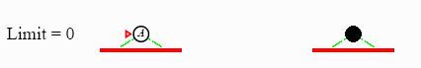
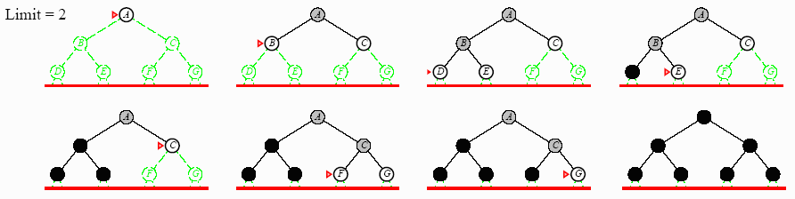
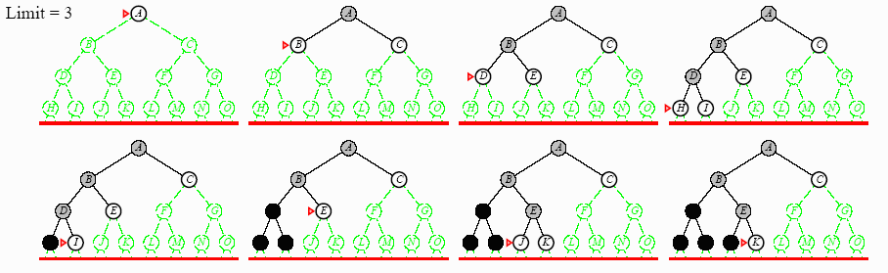

คุณสมบัติ
- ค้นหาโหนดเป้าหมายที่ต้องการได้เสมอ
- คำตอบที่พบจะเป็นเส้นทางที่สั้นที่สุด ก็ต่อเมื่อ path cost เป็น 1 หรือเท่ากันทั้งหมด
- ใช้เวลาน้อย เพราะไม่ต้องติดในเส้นทางที่ลึกมากๆ
- ใช้หน่วยความจำน้อย

โฟลว์ชาร์ต
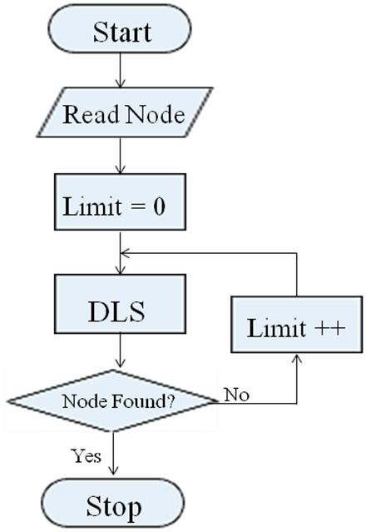

ตัวอย่างโปรแกรม

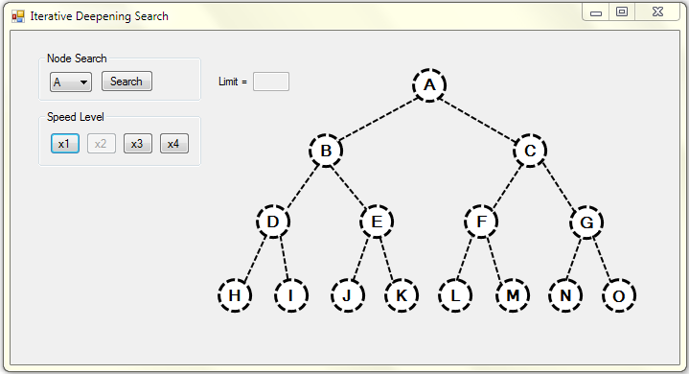

ตัวอย่างผลการรัน : กำหนดให้โหนด K เป็นโหนดเป้าหมาย

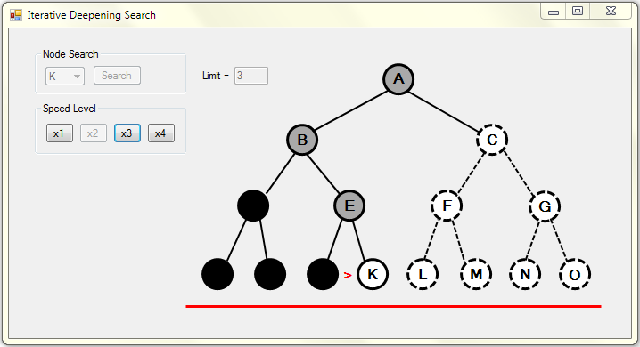

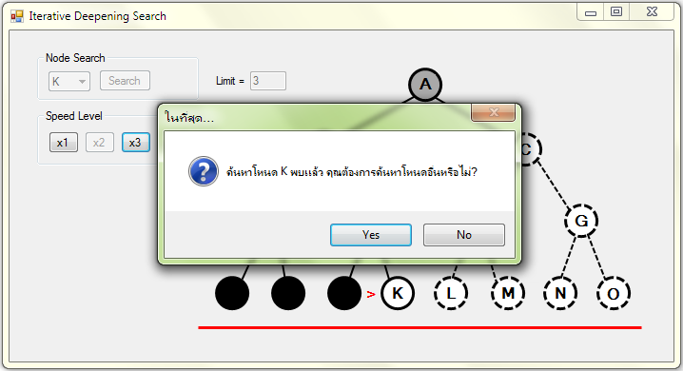

ซอร์สโค้ด (Visual C#)
using System;
using System.Collections.Generic;
using System.ComponentModel;
using System.Data;
using System.Drawing;
using System.Linq;
using System.Text;
using System.Windows.Forms;

namespace AI_Project
{
public partial class Form1 : Form
{
private int Limit = 0, Time = 1000, Step = 0;
private string Node = "A";
public Form1()
{
InitializeComponent();
}
private void Form1_Load(object sender, EventArgs e)
{
ComboBox_Node.SelectedIndex = 0;
Button_Speed2.Enabled = false;
}
private void Timer_Tick(object sender, EventArgs e)
{
Timer.Interval = Time;
++Step;
TextBox_Limit.Text = Limit.ToString();
if (Step == 1)
{
Line_Level0.Visible = true;
Line_Level1.Visible = false;
Line_Level2.Visible = false;
Line_Level3.Visible = false;
}
if (Step == 2)
{
Label_pA.Visible = true;
Node_A.BorderStyle = System.Drawing.Drawing2D.DashStyle.Solid;
}
if (Step == 3)
{
if (Node == "A")
{
NodeFounded(Node);
}
else
{
Node_A.FillColor = System.Drawing.Color.Black;
Label_A.BackColor = System.Drawing.Color.Black;
Label_A.ForeColor = System.Drawing.Color.Black;
Limit++;
}
Label_pA.Visible = false;
}
if (Step == 4)
{
ClearAll();
Line_Level0.Visible = false;
Line_Level1.Visible = true;
Line_Level2.Visible = false;
Line_Level3.Visible = false;
}
if (Step == 5)
{
Label_pA.Visible = true;
Node_A.BorderStyle = System.Drawing.Drawing2D.DashStyle.Solid;
}
if (Step == 6)
{
Node_A.FillColor = System.Drawing.Color.DarkGray;
Label_A.BackColor = System.Drawing.Color.DarkGray;
Label_A.ForeColor = System.Drawing.Color.Black;
Label_pA.Visible = false;
Node_A.BorderStyle = System.Drawing.Drawing2D.DashStyle.Solid;
Line_AB.BorderStyle = System.Drawing.Drawing2D.DashStyle.Solid;
Line_AC.BorderStyle = System.Drawing.Drawing2D.DashStyle.Solid;
}
if (Step == 7)
{
Label_pB.Visible = true;
Node_B.BorderStyle = System.Drawing.Drawing2D.DashStyle.Solid;
}
if (Step == 8)
{
if (Node == "B")
{
NodeFounded(Node);
}
else
{
Node_B.FillColor = System.Drawing.Color.Black;
Label_B.BackColor = System.Drawing.Color.Black;
Label_B.ForeColor = System.Drawing.Color.Black;
}
Label_pB.Visible = false;
}
if (Step == 9)
{
Label_pC.Visible = true;
Node_C.BorderStyle = System.Drawing.Drawing2D.DashStyle.Solid;
}
if (Step == 10)
{
if (Node == "C")
{
NodeFounded(Node);
}
else
{
Node_A.FillColor = System.Drawing.Color.Black;
Label_A.BackColor = System.Drawing.Color.Black;
Label_A.ForeColor = System.Drawing.Color.Black;
Node_C.FillColor = System.Drawing.Color.Black;
Label_C.BackColor = System.Drawing.Color.Black;
Label_C.ForeColor = System.Drawing.Color.Black;
Limit++;
}
Label_pC.Visible = false;
}
if (Step == 11)
{
ClearAll();

Line_Level0.Visible = false;
Line_Level1.Visible = false;
Line_Level2.Visible = true;
Line_Level3.Visible = false;
}
if (Step == 12)
{
Label_pA.Visible = true;
Node_A.BorderStyle = System.Drawing.Drawing2D.DashStyle.Solid;
}
if (Step == 13)
{
Node_A.FillColor = System.Drawing.Color.DarkGray;
Label_A.BackColor = System.Drawing.Color.DarkGray;
Label_A.ForeColor = System.Drawing.Color.Black;
Label_pA.Visible = false;
Line_AB.BorderStyle = System.Drawing.Drawing2D.DashStyle.Solid;
Line_AC.BorderStyle = System.Drawing.Drawing2D.DashStyle.Solid;
}
if (Step == 14)
{
Label_pB.Visible = true;
Node_B.BorderStyle = System.Drawing.Drawing2D.DashStyle.Solid;
}
if (Step == 15)
{
Node_B.FillColor = System.Drawing.Color.DarkGray;
Label_B.BackColor = System.Drawing.Color.DarkGray;
Label_B.ForeColor = System.Drawing.Color.Black;
Label_pB.Visible = false;
Line_BD.BorderStyle = System.Drawing.Drawing2D.DashStyle.Solid;
Line_BE.BorderStyle = System.Drawing.Drawing2D.DashStyle.Solid;
}
if (Step == 16)
{
Label_pD.Visible = true;
Node_D.BorderStyle = System.Drawing.Drawing2D.DashStyle.Solid;
}
if (Step == 17)
{
if (Node == "D")
{
NodeFounded(Node);
}
else
{
Node_D.FillColor = System.Drawing.Color.Black;
Label_D.BackColor = System.Drawing.Color.Black;
Label_D.ForeColor = System.Drawing.Color.Black;
}
Label_pD.Visible = false;
}
if (Step == 18)
{
Label_pE.Visible = true;
Node_E.BorderStyle = System.Drawing.Drawing2D.DashStyle.Solid;
}
if (Step == 19)
{
if (Node == "E")
{
NodeFounded(Node);
}
else
{
Node_B.FillColor = System.Drawing.Color.Black;
Label_B.BackColor = System.Drawing.Color.Black;
Label_B.ForeColor = System.Drawing.Color.Black;
Node_E.FillColor = System.Drawing.Color.Black;
Label_E.BackColor = System.Drawing.Color.Black;
Label_E.ForeColor = System.Drawing.Color.Black;
}
Label_pE.Visible = false;
}
if (Step == 20)
{
Label_pC.Visible = true;
Node_C.BorderStyle = System.Drawing.Drawing2D.DashStyle.Solid;
}
if (Step == 21)
{
Node_C.FillColor = System.Drawing.Color.DarkGray;
Label_C.BackColor = System.Drawing.Color.DarkGray;
Label_C.ForeColor = System.Drawing.Color.Black;
Label_pC.Visible = false;
Line_CF.BorderStyle = System.Drawing.Drawing2D.DashStyle.Solid;
Line_CG.BorderStyle = System.Drawing.Drawing2D.DashStyle.Solid;
}
if (Step == 22)
{
Label_pF.Visible = true;
Node_F.BorderStyle = System.Drawing.Drawing2D.DashStyle.Solid;
}
if (Step == 23)
{
if (Node == "F")
{
NodeFounded(Node);
}
else
{
Node_F.FillColor = System.Drawing.Color.Black;
Label_F.BackColor = System.Drawing.Color.Black;
Label_F.ForeColor = System.Drawing.Color.Black;
}
Label_pF.Visible = false;
}
if (Step == 24)
{
Label_pG.Visible = true;
Node_G.BorderStyle = System.Drawing.Drawing2D.DashStyle.Solid;
}
if (Step == 25)
{
if (Node == "G")
{
NodeFounded(Node);
}
else
{
Node_A.FillColor = System.Drawing.Color.Black;
Label_A.BackColor = System.Drawing.Color.Black;
Label_A.ForeColor = System.Drawing.Color.Black;
Node_C.FillColor = System.Drawing.Color.Black;
Label_C.BackColor = System.Drawing.Color.Black;
Label_C.ForeColor = System.Drawing.Color.Black;
Node_G.FillColor = System.Drawing.Color.Black;
Label_G.BackColor = System.Drawing.Color.Black;
Label_G.ForeColor = System.Drawing.Color.Black;
Limit++;
}
Label_pG.Visible = false;
}
if (Step == 26)
{
ClearAll();
Line_Level0.Visible = false;
Line_Level1.Visible = false;
Line_Level2.Visible = false;
Line_Level3.Visible = true;
}
if (Step == 27)
{
Label_pA.Visible = true;
Node_A.BorderStyle = System.Drawing.Drawing2D.DashStyle.Solid;
}
if (Step == 28)
{
Node_A.FillColor = System.Drawing.Color.DarkGray;
Label_A.BackColor = System.Drawing.Color.DarkGray;
Label_A.ForeColor = System.Drawing.Color.Black;
Label_pA.Visible = false;
Line_AB.BorderStyle = System.Drawing.Drawing2D.DashStyle.Solid;
Line_AC.BorderStyle = System.Drawing.Drawing2D.DashStyle.Solid;
}
if (Step == 29)
{
Label_pB.Visible = true;
Node_B.BorderStyle = System.Drawing.Drawing2D.DashStyle.Solid;
}
if (Step == 30)
{
Node_B.FillColor = System.Drawing.Color.DarkGray;
Label_B.BackColor = System.Drawing.Color.DarkGray;
Label_B.ForeColor = System.Drawing.Color.Black;
Label_pB.Visible = false;
Line_BD.BorderStyle = System.Drawing.Drawing2D.DashStyle.Solid;
Line_BE.BorderStyle = System.Drawing.Drawing2D.DashStyle.Solid;
}
if (Step == 31)
{
Label_pD.Visible = true;
Node_D.BorderStyle = System.Drawing.Drawing2D.DashStyle.Solid;
}
if (Step == 32)
{
Node_D.FillColor = System.Drawing.Color.DarkGray;
Label_D.BackColor = System.Drawing.Color.DarkGray;
Label_D.ForeColor = System.Drawing.Color.Black;
Label_pD.Visible = false;
Line_DH.BorderStyle = System.Drawing.Drawing2D.DashStyle.Solid;
Line_DI.BorderStyle = System.Drawing.Drawing2D.DashStyle.Solid;
}
if (Step == 33)
{
Label_pH.Visible = true;
Node_H.BorderStyle = System.Drawing.Drawing2D.DashStyle.Solid;
}
if (Step == 34)
{
if (Node == "H")
{
NodeFounded(Node);
}
else
{
Node_H.FillColor = System.Drawing.Color.Black;
Label_H.BackColor = System.Drawing.Color.Black;
Label_H.ForeColor = System.Drawing.Color.Black;
}
Label_pH.Visible = false;
}
if (Step == 35)
{
Label_pI.Visible = true;
Node_I.BorderStyle = System.Drawing.Drawing2D.DashStyle.Solid;
}
if (Step == 36)
{
if (Node == "I")
{
NodeFounded(Node);
}
else
{
Node_D.FillColor = System.Drawing.Color.Black;
Label_D.BackColor = System.Drawing.Color.Black;
Label_D.ForeColor = System.Drawing.Color.Black;
Node_I.FillColor = System.Drawing.Color.Black;
Label_I.BackColor = System.Drawing.Color.Black;
Label_I.ForeColor = System.Drawing.Color.Black;
}
Label_pI.Visible = false;
}
if (Step == 37)
{
Label_pE.Visible = true;
Node_E.BorderStyle = System.Drawing.Drawing2D.DashStyle.Solid;
}
if (Step == 38)
{
Node_E.FillColor = System.Drawing.Color.DarkGray;
Label_E.BackColor = System.Drawing.Color.DarkGray;
Label_E.ForeColor = System.Drawing.Color.Black;
Label_pE.Visible = false;
Line_EJ.BorderStyle = System.Drawing.Drawing2D.DashStyle.Solid;
Line_EK.BorderStyle = System.Drawing.Drawing2D.DashStyle.Solid;
}
if (Step == 39)
{
Label_pJ.Visible = true;
Node_J.BorderStyle = System.Drawing.Drawing2D.DashStyle.Solid;
}
if (Step == 40)
{
if (Node == "J")
{
NodeFounded(Node);
}
else
{
Node_J.FillColor = System.Drawing.Color.Black;
Label_J.BackColor = System.Drawing.Color.Black;
Label_J.ForeColor = System.Drawing.Color.Black;
}
Label_pJ.Visible = false;
}
if (Step == 41)
{
Label_pK.Visible = true;
Node_K.BorderStyle = System.Drawing.Drawing2D.DashStyle.Solid;
}
if (Step == 42)
{
if (Node == "K")
{
NodeFounded(Node);
}
else
{
Node_B.FillColor = System.Drawing.Color.Black;
Label_B.BackColor = System.Drawing.Color.Black;
Label_B.ForeColor = System.Drawing.Color.Black;
Node_E.FillColor = System.Drawing.Color.Black;
Label_E.BackColor = System.Drawing.Color.Black;
Label_E.ForeColor = System.Drawing.Color.Black;
Node_K.FillColor = System.Drawing.Color.Black;
Label_K.BackColor = System.Drawing.Color.Black;
Label_K.ForeColor = System.Drawing.Color.Black;
}
Label_pK.Visible = false;
}
if (Step == 43)
{
Label_pC.Visible = true;
Node_C.BorderStyle = System.Drawing.Drawing2D.DashStyle.Solid;
}
if (Step == 44)
{
Node_C.FillColor = System.Drawing.Color.DarkGray;
Label_C.BackColor = System.Drawing.Color.DarkGray;
Label_C.ForeColor = System.Drawing.Color.Black;
Label_pC.Visible = false;
Line_CF.BorderStyle = System.Drawing.Drawing2D.DashStyle.Solid;
Line_CG.BorderStyle = System.Drawing.Drawing2D.DashStyle.Solid;
}
if (Step == 45)
{
Label_pF.Visible = true;
Node_F.BorderStyle = System.Drawing.Drawing2D.DashStyle.Solid;
}
if (Step == 46)
{
Node_F.FillColor = System.Drawing.Color.DarkGray;
Label_F.BackColor = System.Drawing.Color.DarkGray;
Label_F.ForeColor = System.Drawing.Color.Black;
Label_pF.Visible = false;
Line_FL.BorderStyle = System.Drawing.Drawing2D.DashStyle.Solid;
Line_FM.BorderStyle = System.Drawing.Drawing2D.DashStyle.Solid;
}
if (Step == 47)
{
Label_pL.Visible = true;
Node_L.BorderStyle = System.Drawing.Drawing2D.DashStyle.Solid;
}
if (Step == 48)
{
if (Node == "L")
{
NodeFounded(Node);
}
else
{
Node_L.FillColor = System.Drawing.Color.Black;
Label_L.BackColor = System.Drawing.Color.Black;
Label_L.ForeColor = System.Drawing.Color.Black;
}
Label_pL.Visible = false;
}
if (Step == 49)
{
Label_pM.Visible = true;
Node_M.BorderStyle = System.Drawing.Drawing2D.DashStyle.Solid;
}
if (Step == 50)
{
if (Node == "M")
{
NodeFounded(Node);
}
else
{
Node_F.FillColor = System.Drawing.Color.Black;
Label_F.BackColor = System.Drawing.Color.Black;
Label_F.ForeColor = System.Drawing.Color.Black;
Node_M.FillColor = System.Drawing.Color.Black;
Label_M.BackColor = System.Drawing.Color.Black;
Label_M.ForeColor = System.Drawing.Color.Black;
}
Label_pM.Visible = false;
}
if (Step == 51)
{
Label_pG.Visible = true;
Node_G.BorderStyle = System.Drawing.Drawing2D.DashStyle.Solid;
}
if (Step == 52)
{
Node_G.FillColor = System.Drawing.Color.DarkGray;
Label_G.BackColor = System.Drawing.Color.DarkGray;
Label_G.ForeColor = System.Drawing.Color.Black;
Label_pG.Visible = false;
Line_GN.BorderStyle = System.Drawing.Drawing2D.DashStyle.Solid;
Line_GO.BorderStyle = System.Drawing.Drawing2D.DashStyle.Solid;
}
if (Step == 53)
{
Label_pN.Visible = true;
Node_N.BorderStyle = System.Drawing.Drawing2D.DashStyle.Solid;
}
if (Step == 54)
{
if (Node == "N")
{
NodeFounded(Node);
}
else
{
Node_N.FillColor = System.Drawing.Color.Black;
Label_N.BackColor = System.Drawing.Color.Black;
Label_N.ForeColor = System.Drawing.Color.Black;
}
Label_pN.Visible = false;
}
if (Step == 55)
{
Label_pO.Visible = true;
Node_O.BorderStyle = System.Drawing.Drawing2D.DashStyle.Solid;
}
if (Step == 56)
{
if (Node == "O")
{
NodeFounded(Node);
}
Label_pO.Visible = false;
}
}

private void Button_Search_Click(object sender, EventArgs e)
{
Timer.Enabled = true;
Button_Search.Enabled = false;
ComboBox_Node.Enabled = false;
switch (ComboBox_Node.SelectedItem.ToString())
{
case "A":
Node = "A";
break;
case "B":
Node = "B";
break;
case "C":
Node = "C";
break;
case "D":
Node = "D";
break;
case "E":
Node = "E";
break;
case "F":
Node = "F";
break;
case "G":
Node = "G";
break;
case "H":
Node = "H";
break;
case "I":
Node = "I";
break;
case "J":
Node = "J";
break;
case "K":
Node = "K";
break;
case "L":
Node = "L";
break;
case "M":
Node = "M";
break;
case "N":
Node = "N";
break;
case "O":
Node = "O";
break;
}
}

private void ClearAll()
{
Node_A.FillColor = System.Drawing.Color.White;
Label_A.BackColor = System.Drawing.Color.White;
Label_A.ForeColor = System.Drawing.Color.Black;
Node_B.FillColor = System.Drawing.Color.White;
Label_B.BackColor = System.Drawing.Color.White;
Label_B.ForeColor = System.Drawing.Color.Black;
Node_C.FillColor = System.Drawing.Color.White;
Label_C.BackColor = System.Drawing.Color.White;
Label_C.ForeColor = System.Drawing.Color.Black;
Node_D.FillColor = System.Drawing.Color.White;
Label_D.BackColor = System.Drawing.Color.White;
Label_D.ForeColor = System.Drawing.Color.Black;
Node_E.FillColor = System.Drawing.Color.White;
Label_E.BackColor = System.Drawing.Color.White;
Label_E.ForeColor = System.Drawing.Color.Black;
Node_F.FillColor = System.Drawing.Color.White;
Label_F.BackColor = System.Drawing.Color.White;
Label_F.ForeColor = System.Drawing.Color.Black;
Node_G.FillColor = System.Drawing.Color.White;
Label_G.BackColor = System.Drawing.Color.White;
Label_G.ForeColor = System.Drawing.Color.Black;
Node_H.FillColor = System.Drawing.Color.White;
Label_H.BackColor = System.Drawing.Color.White;
Label_H.ForeColor = System.Drawing.Color.Black;
Node_I.FillColor = System.Drawing.Color.White;
Label_I.BackColor = System.Drawing.Color.White;
Label_I.ForeColor = System.Drawing.Color.Black;
Node_J.FillColor = System.Drawing.Color.White;
Label_J.BackColor = System.Drawing.Color.White;
Label_J.ForeColor = System.Drawing.Color.Black;
Node_K.FillColor = System.Drawing.Color.White;
Label_K.BackColor = System.Drawing.Color.White;
Label_K.ForeColor = System.Drawing.Color.Black;
Node_L.FillColor = System.Drawing.Color.White;
Label_L.BackColor = System.Drawing.Color.White;
Label_L.ForeColor = System.Drawing.Color.Black;
Node_M.FillColor = System.Drawing.Color.White;
Label_M.BackColor = System.Drawing.Color.White;
Label_M.ForeColor = System.Drawing.Color.Black;
Node_N.FillColor = System.Drawing.Color.White;
Label_N.BackColor = System.Drawing.Color.White;
Label_N.ForeColor = System.Drawing.Color.Black;
Node_O.FillColor = System.Drawing.Color.White;
Label_O.BackColor = System.Drawing.Color.White;
Label_O.ForeColor = System.Drawing.Color.Black;
Node_A.BorderStyle = System.Drawing.Drawing2D.DashStyle.Dash;
Node_B.BorderStyle = System.Drawing.Drawing2D.DashStyle.Dash;
Node_C.BorderStyle = System.Drawing.Drawing2D.DashStyle.Dash;
Node_D.BorderStyle = System.Drawing.Drawing2D.DashStyle.Dash;
Node_E.BorderStyle = System.Drawing.Drawing2D.DashStyle.Dash;
Node_F.BorderStyle = System.Drawing.Drawing2D.DashStyle.Dash;
Node_G.BorderStyle = System.Drawing.Drawing2D.DashStyle.Dash;
Node_H.BorderStyle = System.Drawing.Drawing2D.DashStyle.Dash;
Node_I.BorderStyle = System.Drawing.Drawing2D.DashStyle.Dash;
Node_J.BorderStyle = System.Drawing.Drawing2D.DashStyle.Dash;
Node_K.BorderStyle = System.Drawing.Drawing2D.DashStyle.Dash;
Node_L.BorderStyle = System.Drawing.Drawing2D.DashStyle.Dash;
Node_M.BorderStyle = System.Drawing.Drawing2D.DashStyle.Dash;
Node_N.BorderStyle = System.Drawing.Drawing2D.DashStyle.Dash;
Node_O.BorderStyle = System.Drawing.Drawing2D.DashStyle.Dash;
Line_AB.BorderStyle = System.Drawing.Drawing2D.DashStyle.Dash;
Line_AC.BorderStyle = System.Drawing.Drawing2D.DashStyle.Dash;
Line_BD.BorderStyle = System.Drawing.Drawing2D.DashStyle.Dash;
Line_BE.BorderStyle = System.Drawing.Drawing2D.DashStyle.Dash;
Line_CF.BorderStyle = System.Drawing.Drawing2D.DashStyle.Dash;
Line_CG.BorderStyle = System.Drawing.Drawing2D.DashStyle.Dash;
Line_DH.BorderStyle = System.Drawing.Drawing2D.DashStyle.Dash;
Line_DI.BorderStyle = System.Drawing.Drawing2D.DashStyle.Dash;
Line_EJ.BorderStyle = System.Drawing.Drawing2D.DashStyle.Dash;
Line_EK.BorderStyle = System.Drawing.Drawing2D.DashStyle.Dash;
Line_FL.BorderStyle = System.Drawing.Drawing2D.DashStyle.Dash;
Line_FM.BorderStyle = System.Drawing.Drawing2D.DashStyle.Dash;
Line_GN.BorderStyle = System.Drawing.Drawing2D.DashStyle.Dash;
Line_GO.BorderStyle = System.Drawing.Drawing2D.DashStyle.Dash;
Line_Level0.Visible = false;
Line_Level1.Visible = false;
Line_Level2.Visible = false;
Line_Level3.Visible = false;
}
private void SearchAgain()
{
Step = 0;
Limit = 0;
TextBox_Limit.Text = Limit.ToString();
ComboBox_Node.SelectedIndex = 0;
Button_Search.Enabled = true;
ComboBox_Node.Enabled = true;
}
private void Button_Speed1_Click(object sender, EventArgs e)
{
Time = 2000;
Button_Speed1.Enabled = false;
Button_Speed2.Enabled = true;
Button_Speed3.Enabled = true;
Button_Speed4.Enabled = true;
}

private void Button_Speed2_Click(object sender, EventArgs e)
{
Time = 1000;
Button_Speed1.Enabled = true;
Button_Speed2.Enabled = false;
Button_Speed3.Enabled = true;
Button_Speed4.Enabled = true;
}
private void Button_Speed3_Click(object sender, EventArgs e)
{
Time = 500;
Button_Speed1.Enabled = true;
Button_Speed2.Enabled = true;
Button_Speed3.Enabled = false;
Button_Speed4.Enabled = true;
}

private void Button_Speed4_Click(object sender, EventArgs e)
{
Time = 250;
Button_Speed1.Enabled = true;
Button_Speed2.Enabled = true;
Button_Speed3.Enabled = true;
Button_Speed4.Enabled = false;
}

public void NodeFounded(string Node)
{
Timer.Enabled = false;
if (MessageBox.Show("ค้นหาโหนด " + Node + " พบแล้ว คุณต้องการค้นหาโหนดอื่นหรือไม่?", "ในที่สุด...", MessageBoxButtons.YesNo, MessageBoxIcon.Question) == DialogResult.Yes)
{
ClearAll();
SearchAgain();
}
else
{
this.Close();
}
}
}
}

